Q2)Ansible

1)create an inventory file

2)create playbook create_user.yml

3)Test connection

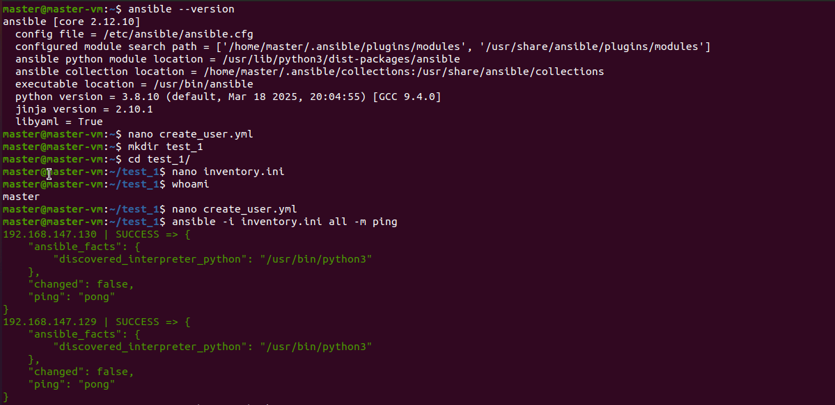

4)Run the playbook

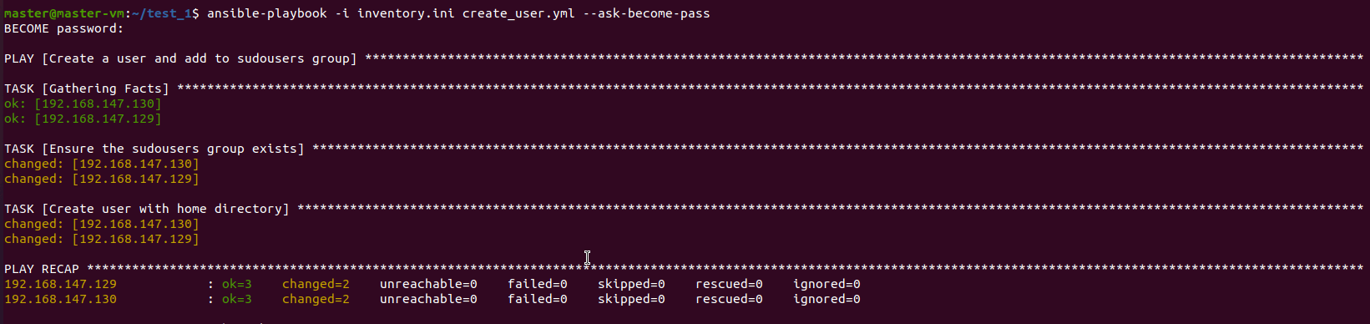

5)Verify the user on remote machines

